Langchain case study

1.FOLDER STRUCTURE:
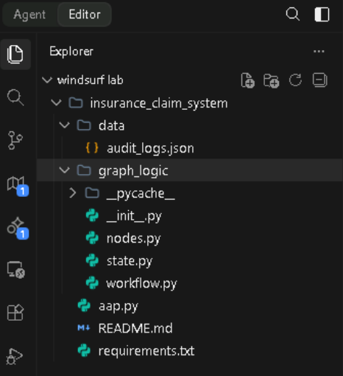

2.Codes:
Node.py:

from graph_logic.state import ClaimState

def claim_validation_node(state: ClaimState):
status = "PASS" if state["claim_amount"] > 0 else "FAIL"
return {"validation_status": status, "audit_log": ["Validated fields."]}

def fraud_detection_node(state: ClaimState):
score = 80.0 if state["claim_amount"] > 50000 else 20.0
return {"fraud_score": score, "audit_log": ["Fraud check performed."]}

def recommendation_node(state: ClaimState):
if state["fraud_score"] > 60:
return {"recommendation": "MANUAL_REVIEW", "recommendation_reason": "High fraud risk"}
return {"recommendation": "APPROVED", "recommendation_reason": "Low risk"}

state.py:
from typing import TypedDict, List, Optional

class ClaimState(TypedDict):
claim_id: str
customer_name: str
policy_number: str
claim_amount: float
validation_status: Optional[str]
fraud_score: Optional[float]
risk_level: Optional[str]
recommendation: Optional[str]
recommendation_reason: Optional[str]
final_decision: Optional[str]
audit_log: List[str]
workflow.py:
from langgraph.graph import StateGraph, END
from langgraph.checkpoint.memory import MemorySaver
from graph_logic.state import ClaimState
from graph_logic.nodes import claim_validation_node, fraud_detection_node, recommendation_node

workflow = StateGraph(ClaimState)

workflow.add_node("validator", claim_validation_node)
workflow.add_node("fraud", fraud_detection_node)
workflow.add_node("recommendation", recommendation_node)

workflow.set_entry_point("validator")
workflow.add_edge("validator", "fraud")
workflow.add_edge("fraud", "recommendation")

def router(state: ClaimState):
return "manual_review" if state["recommendation"] == "MANUAL_REVIEW" else END

workflow.add_conditional_edges("recommendation", router, {"manual_review": "manual_review", "end": END})
workflow.add_node("manual_review", lambda x: {"final_decision": "PENDING_HUMAN"})

memory = MemorySaver()
app = workflow.compile(checkpointer=memory)

app.py:
import streamlit as st
from graph_logic.workflow import app

tab1, tab2, tab3 = st.tabs(["Submission", "Dashboard", "Manual Review"])

with tab1:
st.header("Claim Submission")
with st.form("claim"):
amount = st.number_input("Amount")
if st.form_submit_button("Submit"):
res = app.invoke({"claim_amount": amount, "audit_log": []})
st.write("Recommendation:", res.get("recommendation"))

with tab2:
st.header("Dashboard")
st.write("Monitor agent status and graph path here.")

with tab3:
st.header("Manual Review Queue")
st.write("Claims flagged for manual intervention will appear here.")

3.FINAL RESULT:

